**Throttle Positioning system**

**Name: - Ashish Hatkar**

**Employee ID: - 214590**

**Contents**

|  |  |  |
| --- | --- | --- |
| SR.NO | Topic | Page No |
| 1 | Introduction | 2 |
| 2 | Block Diagram | 2 |
| 3 | Evolution of automotive lighting over the year | 2 |
| 4 | Equation of the Net Movement applied on throttle plate | 3 |
| 5 | Simulink Circuit Layout | 3 |
| 6 | Pin Definition | 4 |
| 7 | Input Blocks | 4 |
| 8 | Output of the System (Data Inspector) | 5 |

**1.Introduction: -**

Throttle is responsible for the regulating amount of fuel that flow into the internal combustion engine. It establishes the essential connection between the acceleration pedal and the throttle valve. Previously it was mainly depending on the mechanical and hydraulics system Now electric throttle system is preferred in the most vehicle. Generally, the electronic throttle employs a closed-looped control algorithm. The desired throttle position is calculated based on the information from both the acceleration pedal and other systems (e.g., engine controller, electronic stability control, cruise control, etc.). The control unit compares the desired throttle position with the actual throttle position and sends the appropriate signal to the motor to drive the throttle to the desired position.

**2.Block Diagram Throttle Positioning System: -**

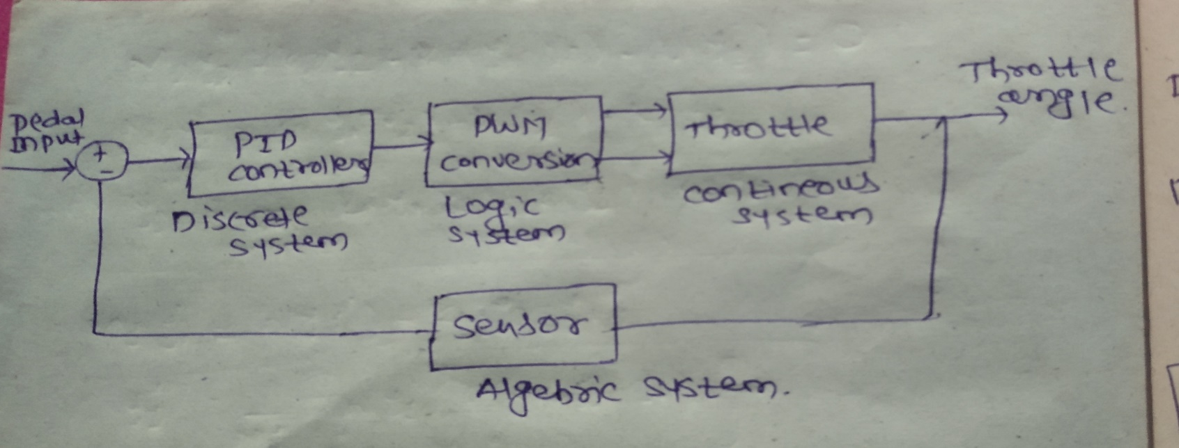

**3.Subsystems of the throttle positioning system: -**

1. **PID Controller: -**

 The actual throttle position is compared to the desired value and the difference between them is sent to a proportional-integral-derivative (PID) controller to generate the input signal for the drive circuit.

1. **Potentiometer: -**

converts variation of angle of position to the variation of angle of voltage.

1. **Feedback Sensor: -**

Feedback sensor is used to measure the angle of position of the throttle plate this feedback sensor also acts the potentiometer and converts variation of angle of position to the variation of angle of voltage.

1. **PWM Conversion: -**

Since system is connected to the acceleration pedal such that they read instantaneous angle made by the pedal position in radians.

To simulate the variation, we need to create PWM the output values then converted to degrees and then pass to 1-D look up table and using linear interpolation.

1. **Throttling System: -**

Throttling valve is a butterfly valve in which the throttle plate rotation is limited between 0 and 90 degree. The throttle plate can be model mathematically summing of the movement of the throttle plate shaft.

**4.Equation of the net movement applied on the throttle plate: -**

**jθ(t)=Σ(t)=Tmotor(t)+Tdamping(t)Tspring(t), θ(t)=**Throttle angle

**Tmotor(t)=**Direction*Duty*Cs **j**=Inertia of the throttle plat constant

**Tdamping(t)=**-ks(θ(t)-θeq) **ks=** Spring Constant, **Kd=**Viscous Friction

**Tspring(t)**=-Kd*O(t) **O(t)**=Throttle angular velocity

**5.Simulink Circuit of Throttle Positioning System:-**

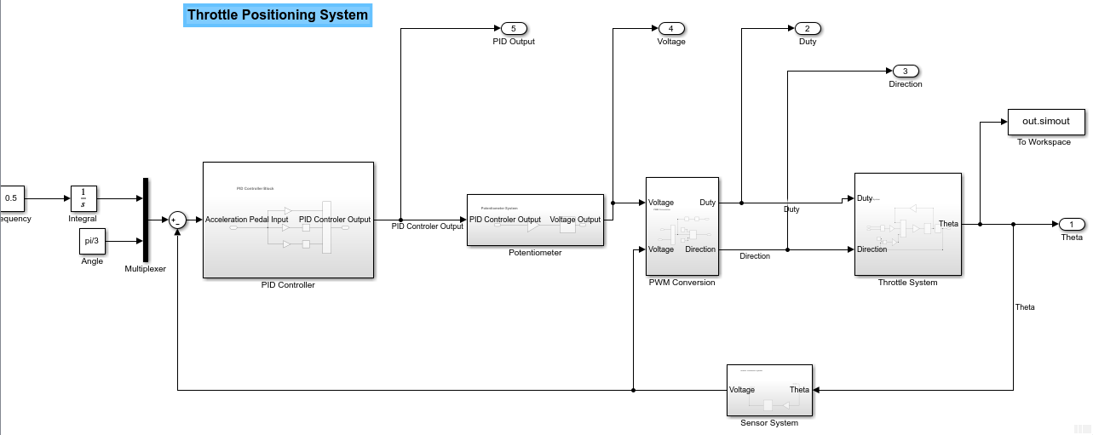

**6.Pin Definition of Throttle Sensor: -**

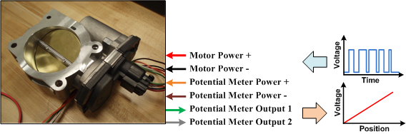

**6.Input and Output of the System: -**

**1 D Look Up table to Convert the Angle values into Voltage: -**

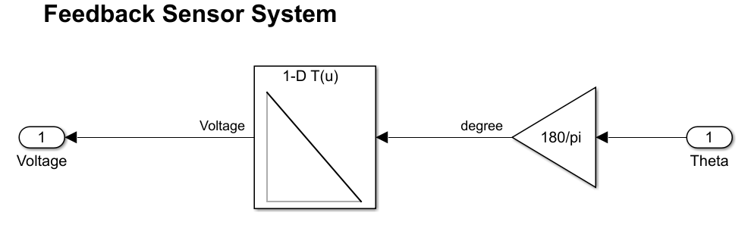

**PWM Conversion System: -**

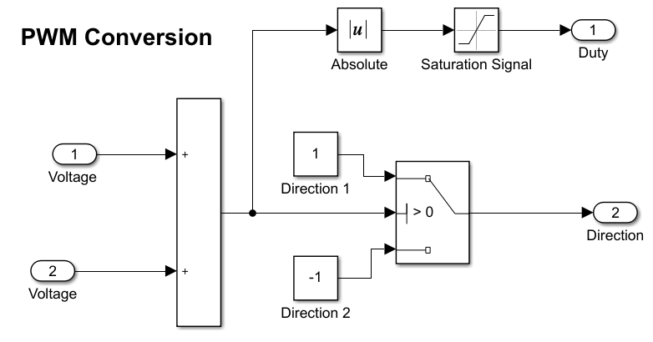

**7.Output of the Throttle Positioning System (Data Inspector): -**

